**BLINKIT ANALYSIS**

**A.KPI’S**

1. **TOTAL SALES:**

SELECT CAST (SUM(total_sales) /1000000.0 AS DECIMAL(10,2)) AS

Total_million_sales

from blinkit_data;

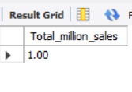

SELECT SUM(total_sales) AS total_sales from blinkit_data

WHERE item_fat_content='Low Fat';

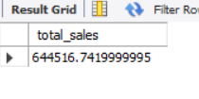

1. **AVERAGE SALES:**

SELECT AVG(total_sales) from blinkit_data;

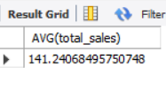

SELECT CAST(AVG(total_sales) AS DECIMAL(10,2)) AS Avg_sales from blinkit_data;

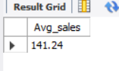

**3.TOTAL ITEMS:**

SELECT COUNT(*) AS total_items FROM blinkit_data;



1. **RATING**

SELECT AVG(Rating) from blinkit_data

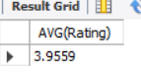

SELECT CAST(AVG(Rating) AS DECIMAL(10,2)) AS avg_rating FROM blinkit_data;

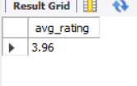

**GRANULAR REQUIREMENTS:**

**1.Total sales by fat content**

SELECT item_fat_content, SUM(total_sales) AS total_sales_sum

FROM blinkit_data

GROUP BY item_fat_content;

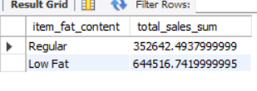

SELECT outlet_establishment_year,SUM(total_sales) AS TOTAL_SALES

FROM blinkit_data

GROUP BY outlet_establishment_year

ORDER BY TOTAL_SALES DESC;

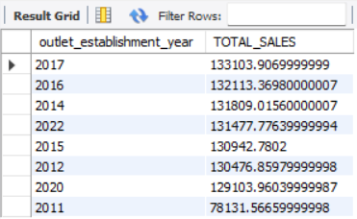

SELECT outlet_establishment_year,CAST(SUM(total_sales) AS DECIMAL(10,3)) AS TOTAL_SALES

FROM blinkit_data

GROUP BY outlet_establishment_year

ORDER BY TOTAL_SALES DESC;

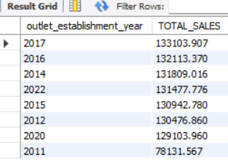

SELECT item_fat_content,

CAST(SUM(total_sales) AS DECIMAL(10,2)) AS total_sales,

CAST(AVG(total_sales) AS DECIMAL(10,3)) AS Avg_sales,

COUNT(*) AS total_count

from blinkit_data

GROUP BY item_fat_content

ORDER BY total_sales DESC;

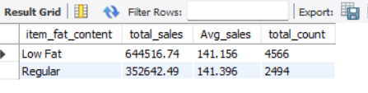

SELECT item_fat_content,

CAST(SUM(total_sales) AS DECIMAL(10,2)) AS total_sales,

CAST(AVG(total_sales) AS DECIMAL(10,3)) AS Avg_sales,

COUNT(*) AS total_count

from blinkit_data

WHERE outlet_establishment_year=2020

GROUP BY item_fat_content

ORDER BY total_sales DESC;

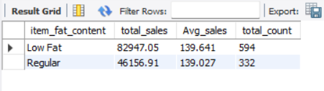

SELECT item_type,

sum(total_sales) AS total_sales,

AVG(total_sales) AS avg_sales,

COUNT(*) AS total_count

from blinkit_data

WHERE item_type='Canned'

GROUP BY item_type;

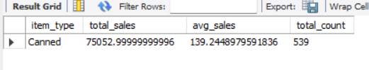

SELECT item_type,

sum(total_sales) AS total_sales,

AVG(total_sales) AS avg_sales,

COUNT(*) AS total_count

from blinkit_data

GROUP BY item_type;

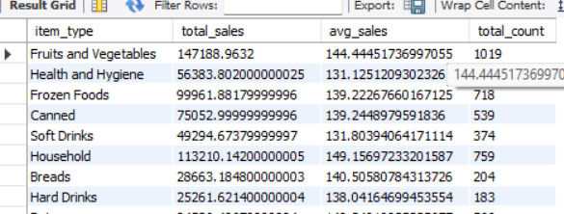

SELECT item_type,

CAST(SUM(total_sales) AS DECIMAL(10,2)) AS total_sales,

CAST(AVG(total_sales) AS DECIMAL(10,3)) AS avg_sales,

COUNT(*) AS total_count,

CAST(AVG(Rating) AS DECIMAL(10,1)) AS avg_rating

FROM blinkit_data

GROUP BY item_type

ORDER BY avg_sales;

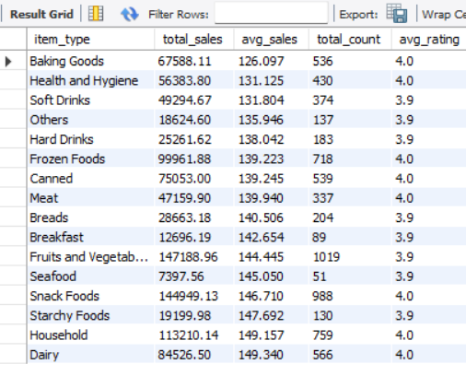

SELECT `Outlet Location Type`,item_fat_content,

CAST(SUM(total_Sales) AS DECIMAL(10,2)) AS total_sales,

CAST(AVG(total_sales) AS DECIMAL(10,1)) AS Avg_sales,

COUNT(*) AS No_of_items,

CAST(AVG(Rating) AS DECIMAL(10,2)) AS Avg_rating

FROM blinkit_data

GROUP BY `Outlet Location Type`,item_fat_content

ORDER BY total_sales ASC

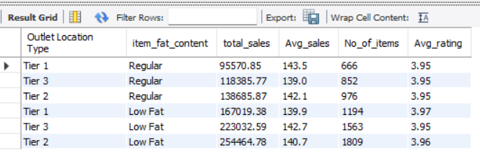

**Total sales by establishment year**

SELECT outlet_establishment_year ,

SUM(total_sales) AS Total_sales

FROM blinkit_data

GROUP BY outlet_establishment_year

ORDER BY outlet_establishment_year ASC

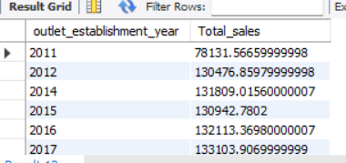

**Percentage of sales by oulet size**

SELECT `Outlet Size`,

CAST(SUM(total_sales) AS DECIMAL(10,2)) AS Total_sales,

CAST((SUM(total_sales)*100.0 / SUM(SUM(total_sales)) OVER()) AS DECIMAL(10,2)) AS sales_percentage

FROM blinkit_data

GROUP BY `Outlet Size`

ORDER BY total_sales DESC

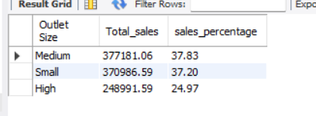

**Sales by outlet location**

SELECT `Outlet Location Type`,

CAST(SUM(total_sales) AS DECIMAL(10,2)) AS Total_sales,

CAST((SUM(total_sales) *100.0/SUM(SUM(total_sales)) over()) AS DECIMAL (10,2)) AS sales_percentage,

CAST(AVG(total_sales) AS DECIMAL(10,2))AS avg_sales,

COUNT(*) AS NO_OF_ITEMS,

CAST(AVG(Rating) AS DECIMAL(10,2)) AS Avg_rating

FROM blinkit_data

GROUP BY `Outlet Location Type`

ORDER BY total_sales DESC;

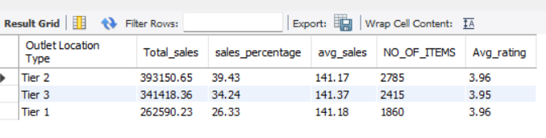

**All metrics by outlet type**

SELECT `Outlet Type`,

CAST(SUM(total_sales) AS DECIMAL(10,2)) AS Total_sales,

CAST((SUM(total_sales) *100.0/SUM(SUM(total_sales)) over()) AS DECIMAL (10,2)) AS sales_percentage,

CAST(AVG(total_sales) AS DECIMAL(10,2))AS avg_sales,

COUNT(*) AS NO_OF_ITEMS,

CAST(AVG(Rating) AS DECIMAL(10,2)) AS Avg_rating

FROM blinkit_data

GROUP BY `Outlet Type`

ORDER BY total_sales DESC;

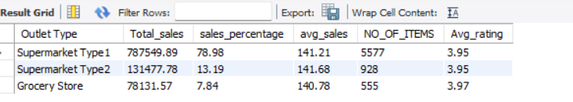

**POWER BI**

**Business Requirements**

**Kpi’s requirements**

Total sales:The overall revenue generated from all items sold

Average sales: The average revenue per sale

Number of items: The total count of different items sold

Average rating: The average customer rating for items sold

DAX CALCULATIONS:

Total sales = SUM('BlinkIT Grocery Data'[Sales] )

No of items = COUNTROWS('BlinkIT Grocery Data')

average rating = AVERAGE('BlinkIT Grocery Data'[Rating])

**chart requirements**

**Total sales by fat content:** Analyze the impact of fat content on total sales

Chart type- Donut chart

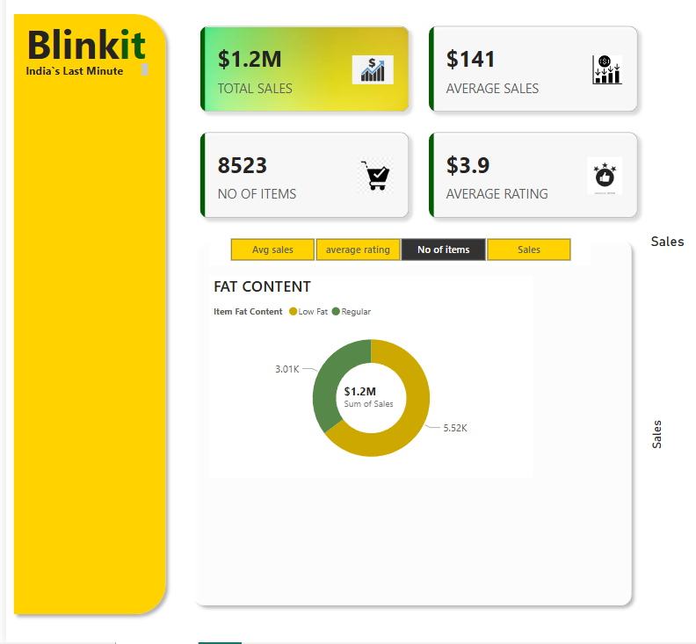

**Fat content by outlet for total sales:** Compares total sales across different outlets segmented by fat content

Chart type: Stacked column chart

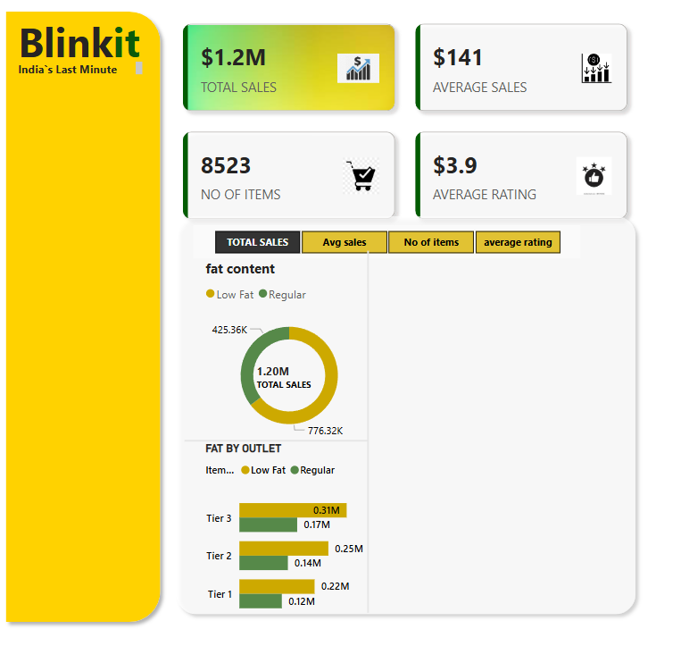

**Total sales by item type:** Identify the performance of different item types in terms of total sales

Chart type: Bar chart

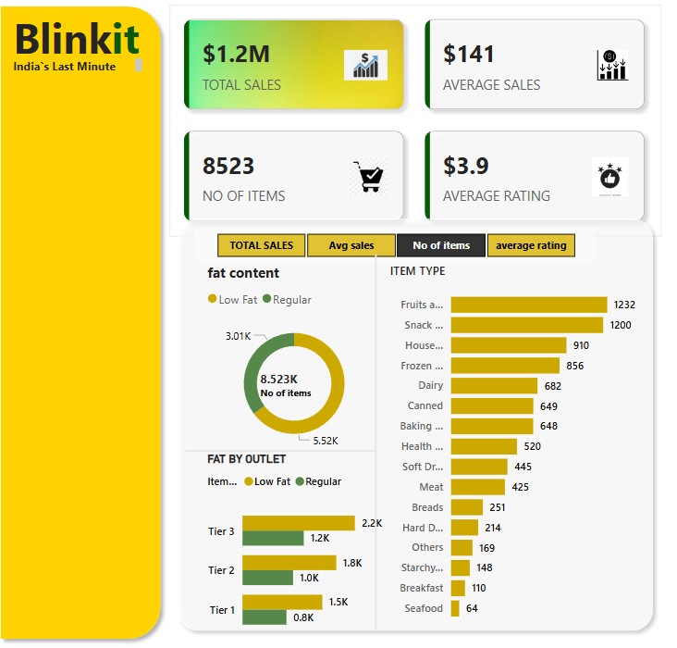

**Total sales by outlet establishment:** Evaluate how the age or type of outlet establishment influence total sales

**Chart type:** line chart

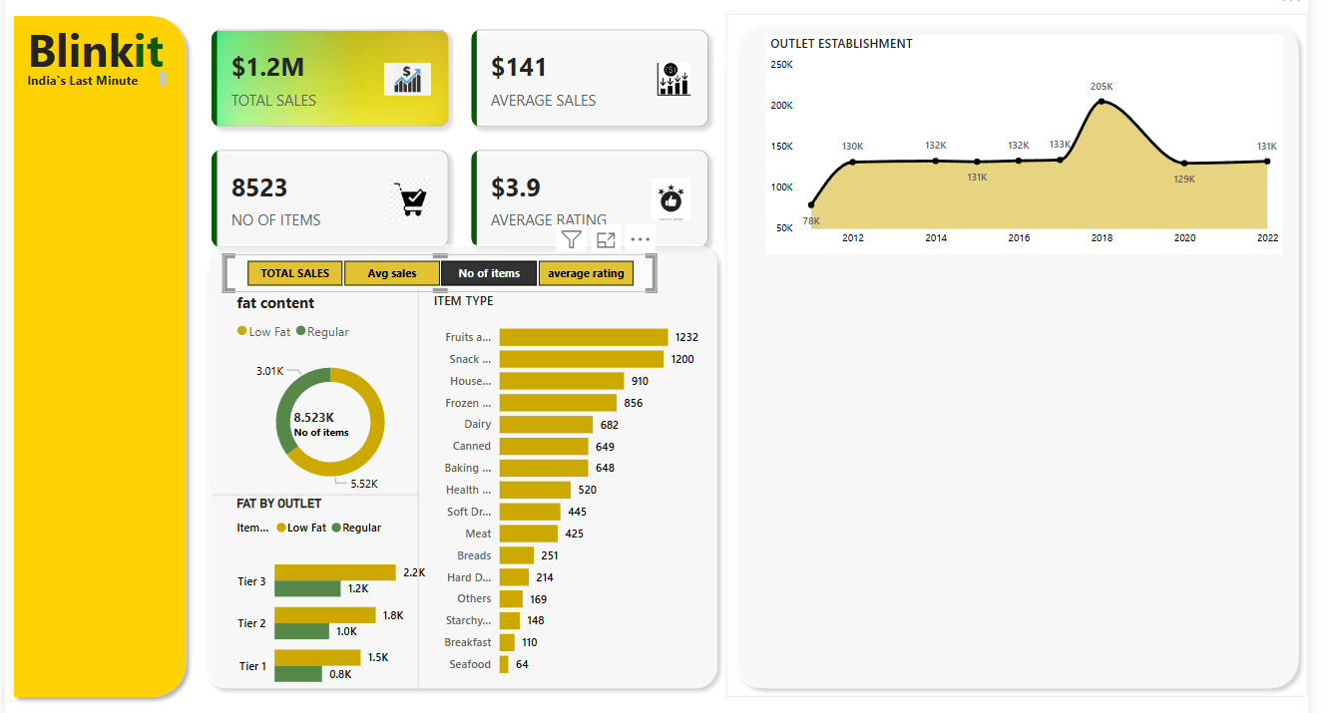

**Sales by outlet size:** Analyze the correlation between outlet size and total sales

**Chart type:** Donut or pie chart

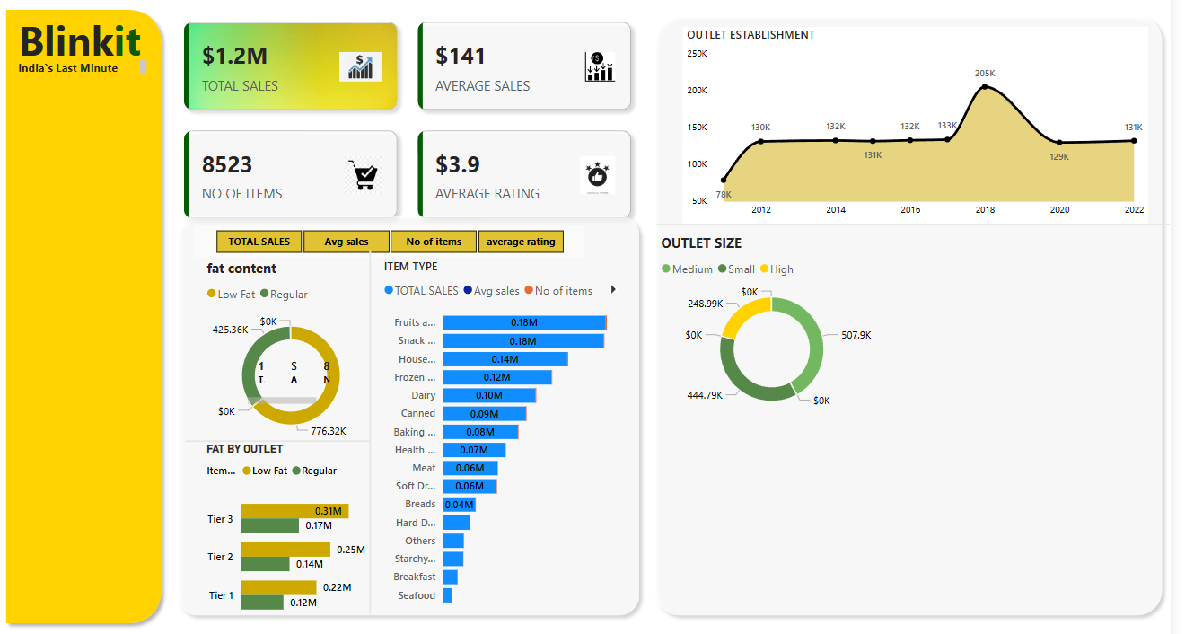

**Sales by Outlet Location:** Assess the geographic distribution of sales across different locations.

**Chart type:** Funnel type

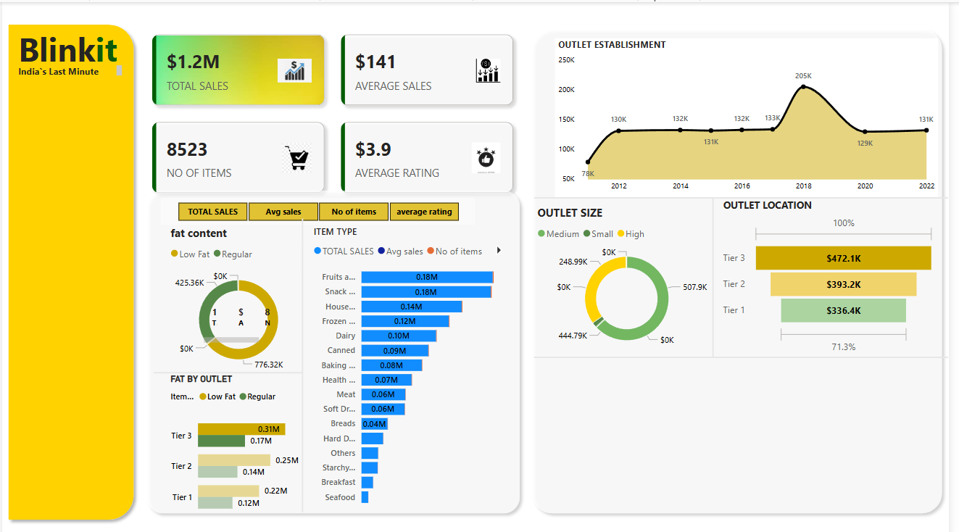

**All metrics by outlet type:** Provide a comprehensive view of all key metrics [Total sales, Aversge sales, Number of items, Average Rating] broken down by different outlet types.

Chart type: Matrix chart

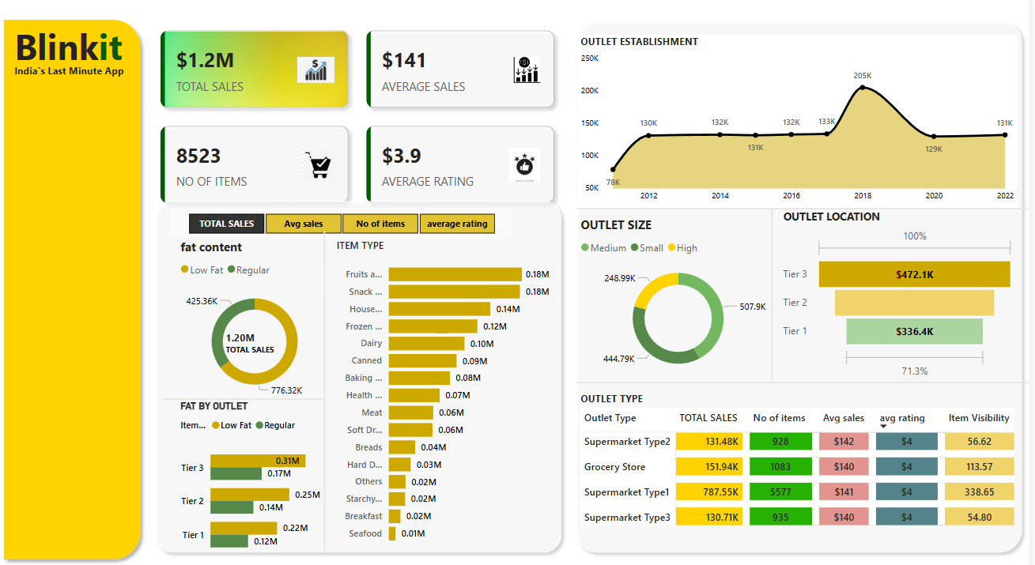

**COMPLETE DASHBOARD**

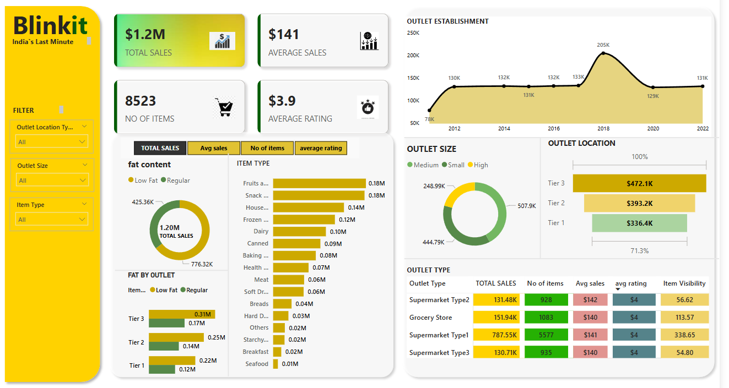

**Dashboard link:** [blinkit dashboard.pbix](blinkit%20dashboard.pbix)